Transfer Learning with Pre-trained CNNs
  - Team: Alpha Neurons [Sonal Shreya, Sumit Kumar Singh]

1. Introduction
Problem Statement
In this assignment, we are going to study the transfer learning process that uses the pretrained CNN models like ResNet for multi-class image classification. We will be using food images for classification. This process is crucial for several applications, including automatic food tracking, calorie estimation, and dietary analysis. The Food-101 dataset is a challenging benchmark for image classification models because it comprises of 101 food categories and 1000 images each. The purpose of this project is to develop a deep learning model based on ResNet-34 and ResNet-50, fine-tune them for classification, and evaluate the performance based on accuracy, F1-score, and confusion matrices.
Dataset Overview
The Food-101 dataset contains 101,000 images divided into 101 classes. Each class has 750 training images and 250 test images. The dataset is well-suited for deep learning applications due to its large size and diversity.
- All images in the Food-101 dataset are of size [128 x 128 pixels].
- They are RGB images with three color channels (red, green, blue).
- Loaded data: 75750 training images, 25250 test images
Dataset Preprocessing
- Resize (224x224): Resizes images to 224x224 pixels to match the input size expected by ResNet models.
- Random Horizontal Flip: Randomly flips images horizontally for data augmentation, helping the model generalize better.
- Random Rotation (15 degrees): Rotates images by up to 15 degrees to make the model invariant to slight image rotations.
- To Tensor & Normalize: Converts images to PyTorch tensors and normalizes pixel values based on ImageNet’s mean and standard deviation to match the pre-trained model's training conditions.
2. Methodology
2.1 Model Selection and Fine-Tuning
We initially experimented with ResNet-34, training it for 10 epochs, which resulted in an accuracy of 49%. To enhance performance, we fine-tuned it by unfreezing additional layers, reducing the learning rate and training for 5 more epochs, achieving the following results:
Fine-Tune Epoch [5/5] - Loss: 0.7794, Accuracy: 77.95%, F1-score: 0.7787
After ResNet-34, we applied the same fine-tuning strategy to ResNet-50, which resulted in improved performance.
Fine-tune Epoch [5/5] - Loss: 0.6202, Accuracy: 82.20%, F1-score: 0.8215
Finally, we unfroze additional layers, further refining the model, training the model for 10 additional epoch and achieving 85% training accuracy, Loss: 0.4801 and 79% test accuracy.
2.2 Training Process
- Batch Size: 32 (reduced to 16 for fine-tuning to avoid memory issues).
- Epochs: 10 (initial training) + 5 (fine-tuning) for ResNet-34, 10 (initial training)+ 5(fine-tuning)+(10 full-finetuning) for ResNet-50.
- Loss Function: Cross-Entropy Loss.
- Optimizer: Adam.
- Evaluation Metrics: Accuracy, F1-score (macro), Confusion Matrix.
- Logging with Weights & Biases (Resnet_transfer_learning) for experiment tracking and visualization.
2.3 Model Evaluation
We evaluated the models using:
- Accuracy: Measures correct predictions across the test set.
- F1-score: Captures class-wise performance.
- Confusion Matrix: Analyzes misclassifications.
2.4 Experiment Run Summary
ResNet-34
- Initial Training (10 epochs)
  - Train Accuracy: 49.86%
  - Train F1-score: 0.4936
  - Train Loss: 2.0179
  - Test Accuracy: 53.00%
  - Test F1-score: 0.5239
- Fine-Tuning (5 more epochs, unfreezing layers)
  - Final Train Accuracy: 77.95%
  - Final Train F1-score: 0.7787
  - Fine-Tune Loss: 0.7794
ResNet-50
- Initial Training (10 epochs)
  - Train Accuracy: 53.54%
  - Train F1-score: 0.5317
  - Train Loss: 1.8821
  - Test Accuracy: 58.34%
  - Test F1-score: 0.5777
- Fine-Tuning (5 more epochs, unfreezing layers)
  - Final Train Accuracy: 82.2%
  - Final Train F1-score: 0.8215
  - Fine-Tune Loss: 0.6202
- Fine-Tuning (Unfreezing additional layers)
  - Final Train Accuracy: 85%
  - Final Train F1-score: 0.8581
  - Final-Tune Loss:0.4801
  - Test Accuracy: 78.83
  - Test F1-score: 0.7875
3. Analysis of Results
3.1 Performance Metrics
Model | Training Accuracy | Fine-Tuned Accuracy | Test Accuracy
ResNet-34 | 49.86% | 77.95% | 53.00%
ResNet-50 | 85.00% | 85.82% | 78.83%
3.2 Visualizations from Weights and Biases
We used W&B for:
- Loss & Accuracy Trends: Showing model convergence.

- Metrics for the final model
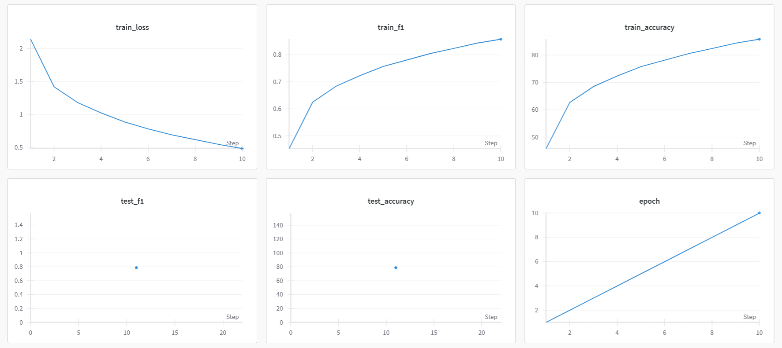

- Overall metrics across all models

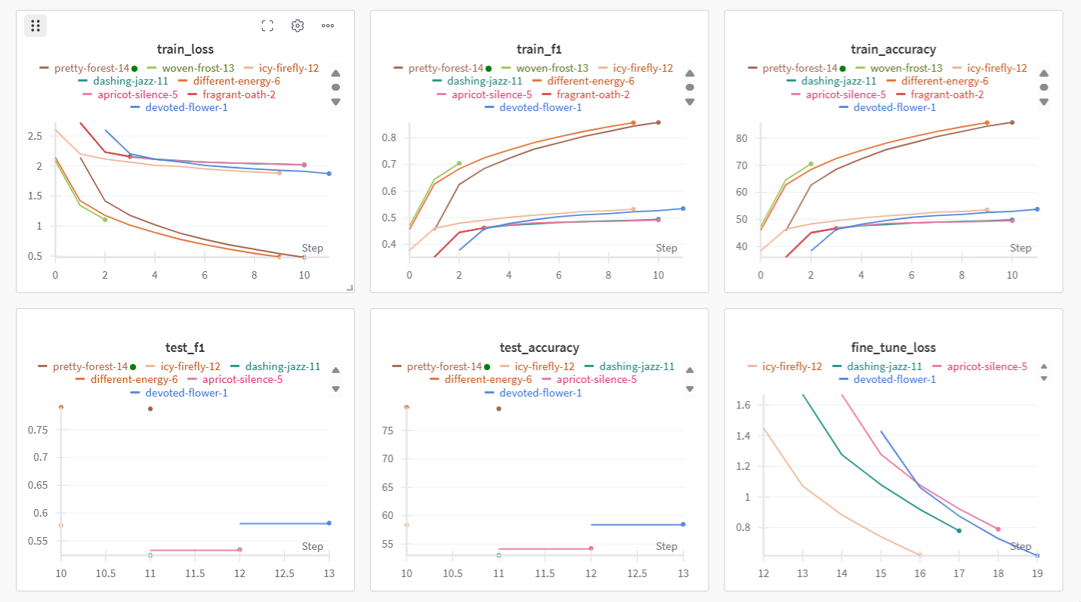
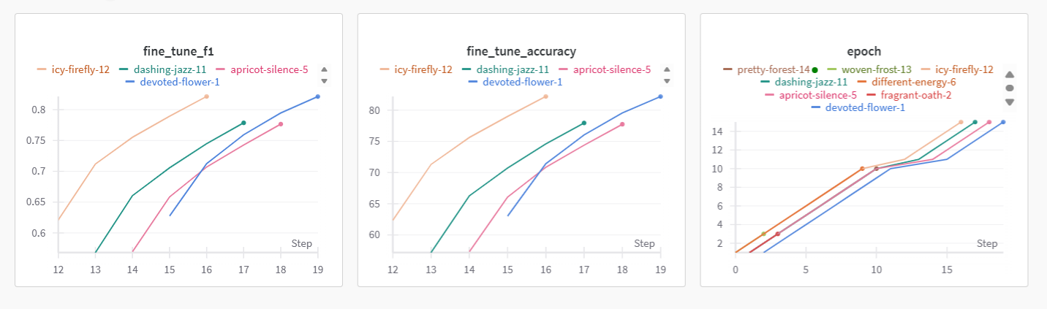

- Confusion Matrix: Identifying misclassified food categories.
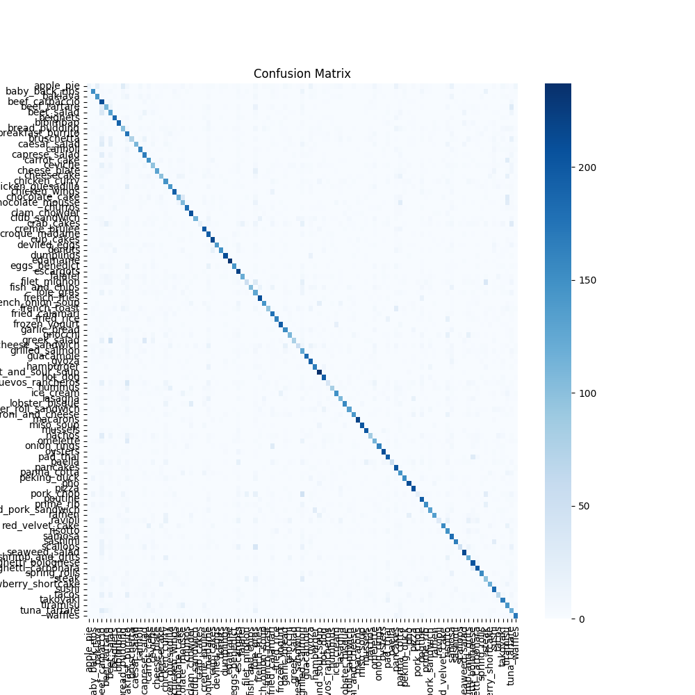
4. Challenges and Solutions
4.1 Computational Constraints
- Issue: Kernel crashes due to high GPU memory usage.
- Solution: Reduced batch size and unfreezing only selective layers.
4.2 Class Imbalance
- Issue: Some classes were harder to classify.
- Solution: Data augmentation (flipping, rotation) and class-weighted loss function.
5. Conclusion and Future Work
Food Recognition using Transfer Learning with ResNet50: In this project we used Transfer Learning by fine-tuning ResNet50 architecture on Food-101 dataset for classifying food images. After unfreezing the layer4 block and training with a custom fully connected layer, the training accuracy was 85.72% (F1-score 0.8571) and the test accuracy was 79.11% (F1-score 0.7906).
Tuning higher layers would help to extract higher quality data which helps to generalize on data that the model has not seen before. The difference between the accuracy of our training set and our test set suggests possible overfitting, which can be avoided by implementing new techniques such as data augmentation, dropout, or fine-tuning further layers.
After fitting the model, it was stored as an artifact in Weights & Biases (resnet50_food101_finetuned), which allows us to load that artifact and run inference or tuning as the next step.
5.1 Summary
- Fine-tuning improved classification performance, with ResNet-50 achieving 85% training accuracy and 80% test accuracy.
- W&B helped monitor training and visualize misclassification patterns.
- Adjustments like batch size tuning, weight regularization, and data augmentation enhanced model robustness.
5.2 Future Improvements
- Try other architectures (e.g., Vision Transformers, EfficientNet).
- Optimize hyperparameters using automated search.
- Add dropout layers and weight decay to prevent overfitting
- Deploy the model as a web app using Flask/Streamlit.
This project demonstrates how deep learning and transfer learning can effectively classify food images, providing valuable insights for AI-driven food recognition systems.
References
- ResNet Architecture - He, Kaiming, Xiangyu Zhang, Shaoqing Ren, and Jian Sun. "Deep Residual Learning for Image Recognition." CVPR, 2016. [Paper]
- PyTorch Documentation - PyTorch: An Open Source Machine Learning Framework.
- Weights & Biases Documentation - Experiment Tracking & Model Management for Machine Learning.
- torchvision.models ResNet50 - Pre-trained deep learning models in torchvision.

Links and Artifacts:
- Weights and Biases Project : Resnet_transfer_learning
- Artifacts: Saved models
- README.md :

